TEDx Lecture on 27 Jan 2019
Story of 2 lives
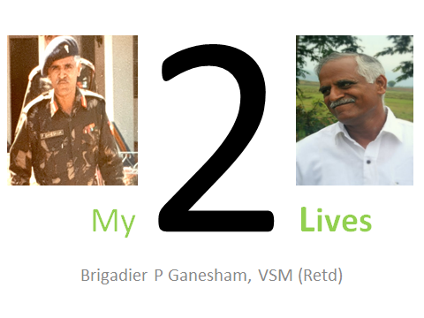
Dear Alumni and Guests
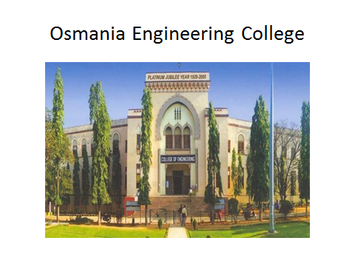
53 years ago in the month of June 1965, I climbed up the 14 steps for the first time to enter our College. I never entered any building of this size before. I came to apply for a seat in this college of Engineering. I came straight to the College from my village wearing shorts and a shirt stitched by mother which made me feel her warmth all the time. Having studied in five schools in villages and towns in AP – now Telangana, I was almost blank in my thoughts. There was no apprehension as my eldest brother graduated from this college in 1960. Guided by arrow signs, walked to the counter next to Principal’s office, handed over the application to the office staff through the big window. He looked at me and with a suspicious expression, said ”does this application belong to your brother?” I do not blame him as I was only 4ft 11 inches. FPS system is ancient to you, but we studied in FPS system and by the time we graduated MKS system had prevailed. SI was nowhere. Thus, started College chapter of my life. I got admission and was also awarded Merit cum means scholarship of Rs 1090 per year. That was sufficient for one year’s fee and deposit for Hostel admission.
Thus, My life – first one, started formally in OUE college. In fact I lived this life – the first one and now the second one is going on. Let me describe my two lives in sequence.
Living in hostel opened Pandora’s Box for me. I saw a great variety around me, which was short in my school days or maybe I was not ready to observe it. Every day I observed something new from faculty, seniors and classmates. Made many friends, some defriended and some befriended. The life after college hours took me to great landscapes of life as the interaction was intense and learning was clearer than what I learnt in the day at College. No offence to the Faculty. I was introduced to a Gymnasium in the cricket ground located in a tin shed hut. Being short, I was advised to run and do gym for faster and impressive growth of the body. I was tempted. Who will not be? Ran round and round in the cricket ground and did some weights in so called Gym. Nothing happened to my physical size. Six months down there was some athletic competition I participated in 5000m race. Can you believe I was declared first in the race? Because at the finishing line there was only one and it happened to be me. I did not compete but I completed the race. First Cup of my life I received and it stayed with me for long though it’s top always use to fall down. Of course, it was my last cup too. There was a lesson in this event. Endurance keeps you up always. This got internalized in me.
College exposed me to Union Elections. First time I saw two friends compete. Plenty of groups are formed, followers line up, canteens get crowded, strategies evolve and some physical fights crop up. No one was sure why they have to go through so much trouble to get elected. There was hardly any agenda, which can be taken up for the sake of students, especially when you have a Principal like legendary “Prof Abid Ali”. I must have seen him five times in five years of my stay in the college. We all were scared of him. I am not sure why? Even now when I look back, there is no answer. But, it could be one reason. We were told that any student caught by him will lose his scholarship. For those who came from villages this was a serious matter. I was one of them. Another lesson: Obedience can be demanded by leveraging insecurity.
National Science Congress was held in 1968 in our University. It was a gigantic event to me. Chief Proctor assigned me the task of Reception- in- charge at Secunderabad Railway Station. An amazing experience of working 48 hours with fellow students without cell phones and no phones at all. Great coordination and purely based on trust that - ‘I told him and he will do it’. It happened. Though we did not get flowers and praise, we did not receive brickbats too. First time in my life, I learnt, logistics, coordination, standards, behaviour with variety of delegates coming from across the country. Lesson: If you are focused and perform with curiosity a lot can be done.
I saw one of the evenings of the Science Congress, Bharata Natyam dance by Yamini Krishna Murthy. It was the first time in my life that I had seen a dance live. Sitting on the lawn very close to the stage, watched the Tillana dance item performed by her in the Landscape Gardens. Oh My God, She was beautiful and looked like a goddess in various Bhangimas. I liked all six items of dance. Next few nights, she occupied all my dreams. Another lesson: Never look at beautiful and talented women closely. You spoil your sleep next few days.
1969 – a watershed in my first life. It started with public protests for employment to Telangana graduates especially engineers. Hostel D and E were the bed of hyper activity in January 1969 where it all started. I was an active participant to learn what it implies? A week of protests, innovative methods to get RTC bus tires punctured innocently and then it turned violent. I was not prepared for it. Few burnt the belongings of fellow students from Andhra in E Hostel. We were friends till now and no longer now onwards. I was in total disagreement. Then the worst happened. Two of my friends and classmates, were caught in the fire which they lit it to burn Jamia Millia railway station master’s office. It was terrible. They were there and they were not there next hour. Imagine the plight of their parents and family. Violence crept into the hitherto peaceful protests. I saw insanity in the method. It changed my perspective of protest. High impact lesson: Protests should not lead to losses to any.
Murder of George Reddy, brother of my classmate Cyril Reddy was another big shock and a harsh reality of confrontations among people. A big lesson: Ideological differences should lead to debates and arguments and never to confrontation resulting in physical hurt and subsequent pain to many.
Each one at some time in life faces a ‘Defining Moment’ of life. I had one in college and more so in this same Assembly Hall in 1970. Of course it is always retrospective. I did not know that on that day.
While sipping one by two chai in Dayanand’s Canteen, my friends asked me to accompany them to a meeting in assembly hall where Indian navy was looking for potential engineers under University Entry Scheme. I was reluctant to go as Armed forces career was never on my radar. I thought my short stature does not qualify me for Armed forces. Such was the ignorance. Not much was available in terms of information. Radio in the Hostel never worked. Newspapers would be gone in 30 minutes of their arrival from reading room. Not many guest speakers used to come to talk to students. It was almost a blind era. Well, going back to the canteen scene, my friends pulled me to the assembly hall. Proceedings began and there were lectures by few of college faculty and the NCC officer. 15 minutes down the programme, something on the stage made me sit up in the chair. You know what I saw. A smart and energetic Navy officer with sparkling white uniform and shining stars was addressing the gathering. And he was of my height. By then, I was 5 feet 3 inches. Lo!! I changed my stand towards Armed Forces. Appeared for the interview on the same day got selected and later next day was subjected to medical examination too at Military hospital, Secunderabad. 8 out of 156 appeared were selected and Listen. I was one of them and the rest is history. Indian navy for some administrative reasons cancelled the University entry scheme. But with the confidence I gained during their visit to the college, I joined the great Indian Army in August, 1972 and retired as a Brigadier in October 2005 with President of India awarding me “Vishist Seva Medal” on the occasion of Republic Day 2005. I hope you are now convinced that this Assembly Hall gave me the “Defining Moment” of my life and I am sure for many it did.
Life in the Army was splendid. Starting with training at Indian Military Academy, 35 years were full of challenges, very high exposure to nature, technology and people of all hues across the country. Living in the Cantonments is like living in a mini India with no chaos, but great camaraderie, equality and feeling of oneness.
I would like to share the oath we take at the completion of officers training at IMA, Dehradun which sums up what Indian Army officers are trained for and why Indians firmly believe that Army is the best Professional and patriotic organization. These words are written on the wall of the hall in the Chetwood building of IMA HQ.
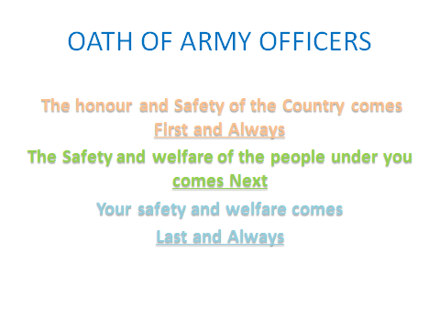
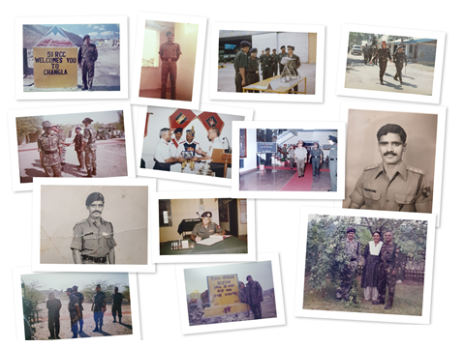
Having lived fully an exciting, meaningful and professional life in the Indian Army, let me share my wish. I would join the Indian Army again and again in my next 100 lives. I am sure you feel the same if you live once in the Armed Forces.
31 October 2005, was the last day I wore Army uniform. As it is said, I hung my boots and came to this beautiful city to spend my residual life, with lock stock and barrel, among my people and the familiar Hyderabadis. I was 56 years then.
Now let me share my Second life which started on 20 November 2005.
Few months I worked for an IT firm as Vice President and eventually assumed the appointment of Director in Bharat Dynamics Ltd, Hyderabad. Whatever it is, final retirement was imminent when I reach 60. I was preparing myself for it and contemplating the life I lead as a retired person. I was not tired only retired.
While in the Army we worked on Innovation Post Kargil and benefitted a lot by it. We saw the power of innovation of a soldier which ensured man- machine compatibility despite the large gap in the technological levels. I started believing in the individual creativity despite the education, position and money. Based on this conviction, we built a unique multi weapon platform which was tried out successfully by the Commanders in all terrains. Finally it was show cased on the directions of Raksha Mantri in the Republic Day Parade 2014. It was a moment of pride for all those who were involved and made it possible. This also happens to be first Patent for the Indian army. Anand Mahindra recommended me to be part of the Governing Council, National Innovation Foundation. That is where I had the opportunity to meet DR R A Mashelkar and Prof Anil K Gupta – who conceived and established National Innovation Foundation (NIF) in 2000.
At NIF, we saw hundreds and thousands of creative solutions developed by the grassroots innovators scouted by the volunteers of Honeybee Network which were nurtured and disseminated across the Nation. This manifested my conviction of ‘Creativity everywhere’. Having participated in few Governing council meetings, I noticed that not much was happening in undivided AP related to capturing grassroots creativity. I was told that lack of volunteers was the primary reason. I saw the opportunity and was drawn towards it.
All through my life, one question bothered me. Is there an alternative to work and deliver without an organization, without resources, vision, mission and objectives? While I enjoyed the benefit and also working in various organizations in 60 years of my first life, this question was inside me and was seeking an answer.
When you retire, you are free from organizational bandhans, and no longer need to role play in the society. You stop belonging to some group and seen by the Society as an individual. That is a great advantage as you find yourself enjoying the greatest autonomy in deciding the course of your life. This autonomy led me to experiment to find answer to the question tucked in a corner of my brain.
I reached Hyderabad on 5 November 2005 and formed “Palle Srujana” on 20 November. Retrospectively speaking, I think it was the best decision of my life.
Many decisions followed. I decided not to earn money any more. I decided to work for the society whatever I can and whoever approaches me as long as it is ethical and made few happier. Simply, I decided to spend my time, money and effort (samay, arth and shram) for others. It was not easy to convince the family. Eventually they accepted a bit reluctantly and also blindly because none of us knew what it involves.
I started with the task of scouting the creativity in the informal system - villages, remote areas, urban slums, elders, children and women and disseminate horizontally. No one understood what I intend to do. I am sure at this point, you too have not understood. Between us, I wasn’t sure too. But I had the conviction that what I intend to do was correct and good for the society at large.
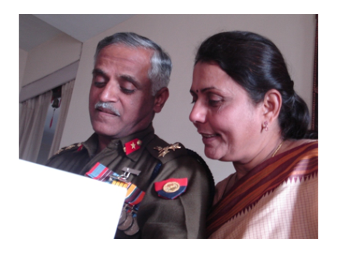
Aruna, my wife who happens to be here listening to me and may be recalling all those days where she worked for Palle Srujana, made our home a public place with people from all over the state from all sections visiting 24 hours, take care of them, attending to calls, compiling information for the magazine, bearing loneliness with courage at home when I visit villages sometimes for 7 -10 days. I knew, it was not easy for her. She supported me fully and there is no way I could have moved on and carried Palle Srujana till date without her physical, emotional support. She had forgiven hundreds of times for moving my attention away from our house and children – bluntly put it was an act of indifference on my part. How do I express my deep gratitude to her for silently suffering and allowing me to do what I did for the last 13 years? Was I unfair to her and selfish to do what I wished to do? Anybody’s guess.
I walked into villages, connected with - my brother–in- law Dr K L Rao and my old roommate in the Engineering college hostel- PCK Sharma, an alumnus of our college from Mining 1971 batch. They supported me from the first day and we moved on. 20 November 2005, precisely 20 days after my retirement from the Army, Palle Srujana was formed. An exciting and meaningful journey had begun.
My friend asked me what you will do in a village. I was not sure about the answer to his question. I had no knowledge of farming, weaving, pottery or animal husbandry. I was not keen to conduct awareness programmes about govt policies. I knew nothing about their life and their needs. That means I am zero for them. I found my answer. I am zero at the age of sixty and let me learn to and grow as I did when I was a child. Dear friends, I decided to learn all over again, from zero in the next 10-15 years of life the good habits from the Army possibly gave me. I unlearned and shed my baggage and tried to melt my ego to convert into a simple, single, and childlike human. It was not easy at all.
We walked into villages. They ask you who you are. Our visiting card an important piece of paper in the formal system does not help there. They would like to know you as what you are or by the post in the govt, political party or religion you belong to. I used to respond to them that I am none and I came to learn from them. They never believed me at the first instance. I used to insist making them comfortable through my voice, deed and thought – “manasa, vacha, karmana”. It was never easy, But I learnt and evolved after many failures. My age, my village background, my understanding of the villager – nature relation, their aspirations, and the influence of the divide between them and the urban lot etc, helped me to hasten the process of proving that my intent was genuine. Trust followed. We evolved and understood the fact that both sides need to be acknowledged rather than invalidated by the other.
Met one Innovator G Chandrashekhar from Kalahasthi an amazing person with humble background and full of passion in whatever he does and plenty of compassion for the fellow beings, animals and nature. Mark the three important words - Innovation, Passion and Compassion. These three magic words rarely found in the formal system provide you a life full of meaning, excitement and purpose. I encountered these in my second life always wherever I went. In one year we found five innovators from Adilabad to Chittoor and Rangareddy to Srikakualam. We restricted the geographical periphery as the state of undivided Andhra Pradesh.
We nurtured them, shared their innovation with NIF, many Institutions and many people. It was going no where. I knew, when we need to make a new path in an unknown area, the pace is always slow and disappointing. I knew my friends and close relatives were disappointed by me but was decent not to share the same on my face. My aim was to pursue the mission I decided and never was my aim to make people around me comfortable about me. May be a discourteous and a bit uncivilized approach, I guess. But I pursued.
Gandhiji influenced me a lot in my youth. I read a lot about him and his splendid ability to connect with masses. At every step, and whenever I faced a dilemma, I used to refer to Gandhiji’s life. I always got an answer. In fact he said once that ‘Dilemma is not unique but the solution is’.
I felt that if one starts a new movement, it needs to reach people whom you do not meet. Print media is one of the options to reach people in remote places. I decided to publish a magazine on the name of the organization “Palle Srujana”. I was never a journalist nor known for even decent articulation in my written or oral expression. Being away for 35 years from Telugu land, my Telugu basic writing skills also were to be rediscovered. I was fortunate to have been introduced to Palle Raghava Reddy a young man in late thirties with journalistic skills and ran a printing press. Aruna my wife was a great help as he kept her love for Telugu wherever she went with me in my Army career. We three took a step forward and published the first magazine and launched By Late Padma Vibhushan Dr Pushp Bhargav and Prof Anil K Gupta from IIM, Ahemadabad in May 2006. In 2009, Jammalmadaka Sesi Mohan garu joined as Editor and has taken on his shoulders. Except the printing cost, all work related to the magazine has been voluntary and we pay none. I am happy to inform you that we are still publishing it, now as bi- monthly since 2012 and in the thirteenth year – uninterrupted. The magazine is purely subscription based and we do not accept sponsors and advertisements. Bapuji said” If you have financial freedom, freedom of Expression is guaranteed”. We have many stories to tell about the magazine and its journey - may be some other day.
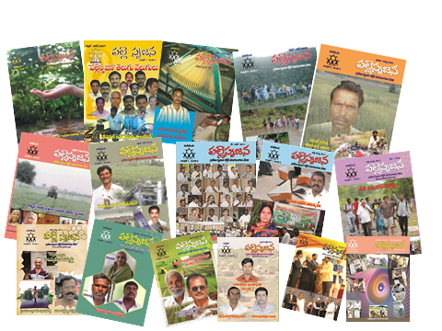
We found Chinthakindi Mallesham in 2007. He was awarded by the President of India and it happens to be the First President of India award for an innovator scouted by Palle Srujana. Our excitement knew no bounds. Today we have 12 more grassroots innovators awarded by the President through the dedicated efforts of Volunteers of Palle Srujana. I am sure that most of you are aware that Mallesham was also awarded “PADMASHRI” in Jan 2017 due to the direct efforts of Palle Srujana. He got many regional, National and International awards and recognition, thanks to the dedicated efforts of volunteers.
Scouting became intensive as many Innovators were searched by the increasing number of volunteers - girls, boys, executives, retired officers, farmers, Politicians, beaurecrats, innovators, subscribers to the Palle Srujana magazine, Press both print and electronic - everyone in the society pitched in and enlarged the Palle Srujana Kutumbam, month by month. Like and unlike minded joined. Jagarlamudi Durga Prasad garu- a businessman with an aim to help the people joined in 2007, Jammalamadaka Srikar garu with a vast experience of banking and working in rural areas in 2009 and Prof K L Chugh – an academician and defence quality expert in 2017 provided strength to the Core group of Palle Srujana by connecting to various sections of formal system Nationally and Internationally including govts, corporates and individuals.
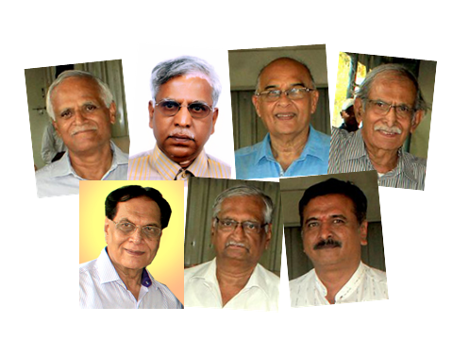
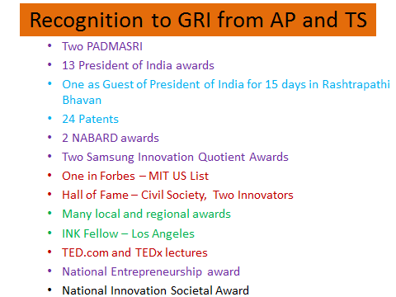
Today Palle Srujana has over 2000 volunteers of all ages, spread across the Telugu states. They scout for innovators and document their knowledge with the permission from the innovators. Palle Srujana value adds, validates, supports in making prototypes and once the innovation is ready for sale, capacity building of the innovator is undertaken. Provides them exposure through exhibitions from rural to National level, includes in the Palle Srujana magazine and recommends them for awards at regional, National and International levels. Applies Patent for their innovations. All this activity is done with passion by volunteers of Palle Srujana. Should the Innovator is not keen to undertake manufacture by himself, we arrange connectivity with manufacturer and ensure that he gets his royalty or value for technology transfer or patent. Last 13 years saw over 200 innovators scouted, 12 Rashtrapathi awards received by the nameless faceless people, 2 Padmashri awarded, One National Entrepreneur Award, 25 patents, over 50 products ready for sale. Their gross turnover last financial year was 5 crores and this year it is likely to cross 7 crores. At a pessimistic estimate, grassroots innovations disseminated by Palle Srujana in the last 10 years surely benefitted over 5 lakh Telugu families. Pan India sales are also increasing with distributors contacting for dealership.
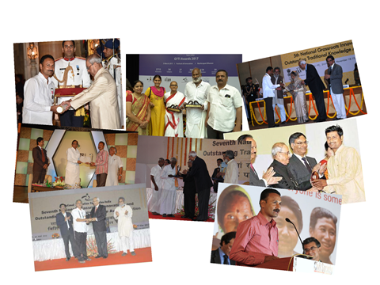
While innovation is in total control of the innovator, manufacture and marketing is not as it involves many external agencies on which the innovator has no control. This is a big challenge especially in the areas of funds and market. Palle Srujana for obvious reasons preferred to connect with individuals for support. We were never disappointed. Some help came from NIF too. Funding over Rs one Crore has been received from the people across the world and it always was sent directly to the innovators account. Palle Srujana only provided the credibility of seeking funds, and ensuring proper utilization. Some of them came in the form of grant, zero interest, soft interest etc. There was no paper work, the contributors have never seen the innovators yet the support was enormous and poured in from all quarters of the Society. I guess, all the while people want to help. They look for a credible platform and I guess Palle Srujana provided to some extent. I hope you see the difference in this method and crowd funding.
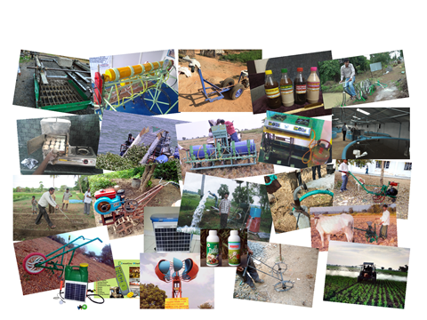
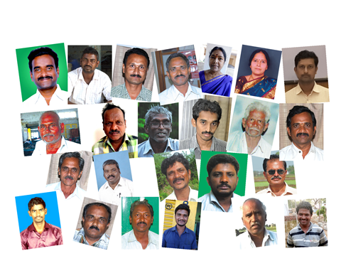
Innovations we scouted are mostly pain killers. When people are frustrated and helpless, they get angry. It happens to all of us. Most of them when in anger resort to actively voicing the problem but few become innovators as they want to solve the problem than shout about it. We call them grassroots innovators. They adhere to the principle of “More from less for more and more..”- A Gandhian approach which ensures sustainability. They make innovations affordable and appropriate. Focus is always on people not on technology or business. Mallesham saw his mother suffering while doing manual asu for ikkat saris and made an Asu machine to reduce mother’s pain. Panduranga rao felt the pain of pushing punctured bikes for miles in rural areas and found a liquid after 8 years of struggle, which when poured in a bike tube about 250 cc will ensure that the tube lasts without any punctures for over 3 years. Isn’t it a real painkiller?
Shanmukha rao developed a simple shade for farm labour to provide them shade while working in open dry or wet fields. He ensured that the farm labour when they get home in the evening does not carry stress from the day’s work and peace is prevailed at homes of crores of families. Rajanna’s empathy to animals made him treat animals voluntarily visiting them every two days till they are normal. His treatment for Mastitis in animals got patent internationally. Mahipal chary made a weeder which is very effective and addresses all the issues of the small farmers and is in great demand. Thirupathi Rao innovated a simple pole climbing device which increases safety and productivity many folds. Chandrashekhar found solutions to pains, wound healing and anti-mosquito in herbs available in his village and marketed “SRITAILAM”. He also found a herbal solution to destroy nematodes which is a big concern in the world as billions of dollors are lost due to nematode attack on plants. Latest in the line from him being a plant based weed destroyer in crops which is not harmful to the main crop. Babu Rao made a manual seed dispenser for small and marginal farmers, which is very popular with tribals. Seeds, Pedal pumps, solar sprayers, fertilizer dispensers, Nose filters, Room air cleaners, growth promoters, human and animal health related formulations based on nature, multipurpose beds and other devices for the disabled - all these are part of the grassroots innovations Palle Srujana found in these nameless and faceless people. We give them a name by projecting their unique innovation or knowledge to the system. This is the main task of nationwide Honeybee network which is virtual and voluntary and Palle Srujana is part of it.
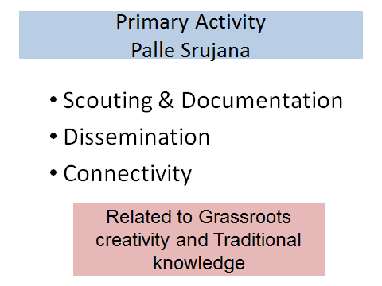
People on the margin do not have marginal minds as you can see from the unique grassroots innovations. These innovators believe that poor should be given the best quality. As Dr R A Mashelkar said we must strive to provide them an “An affordable Excellence”. Grassroots innovators use local technology and local resources thus facilitating easy maintenance and modification. For these innovations, post-sale service is almost zero making the farmers independent. All these innovations are appropriate and affordable.
Somewhere down the line education system started alienating from the society instead of engaging with it. This resulted in neglect of traditional knowledge and practices prevailed over centuries and they are in a state of totally fading away. It is said that “Every old person dies, a Library is burnt.” In heritage, we need to pass on the knowledge too to the next gen along with material benefits such as land, gold and money. Palle Srujana connects school and college students with many of its interactive on the field programmes with the society from which they come from. These initiatives have influenced thousands of students. Some college students through interaction with villagers addressed their technological issues and got patents for their solutions. Palle Srujana has signed MoUs with colleges to provide internship and connectivity to the society. We even authored syllabus for two subjects for introduction in First year of Engineering in 14 autonomous colleges in three states. No classroom learning. TSCHE and APCHE are now seriously considering introducing them in all engineering colleges.

Palle Srujana is basically involved in scouting, dissemination and communication. I spoke about scouting already. We disseminate the innovations through Palle Srujana magazine, exhibitions and Shodha yatras. Let me describe shodha yatra to you. I am sure few of our alumni have participated in it. It is a walk to the forgotten temples of knowledge. It is education beyond walls. It is a walk into unknown, in an unknown context, to learn from unknown people with unknown objectives and agenda. It is a walk of 55-60 kms in three days in the nature learning from people, fellow yatries and self in an environment of equity, curiosity and love. It is for all – boys, girls, adults, women, and elders. One thing is assured for the yatries. They no longer fear the unknown. We disseminate the innovations and also scout for new. The yatra is dreamlike and I strongly recommend all of you to experience this unique WALK- Witness, Accept, Love and Learning and Knowledge.
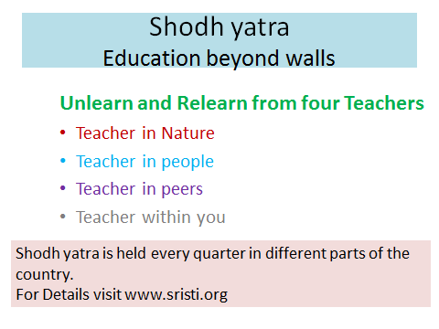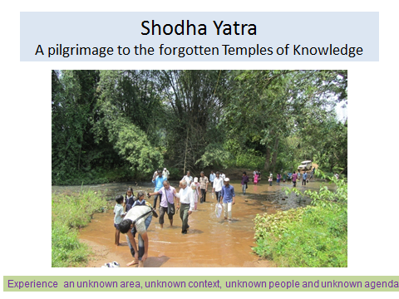
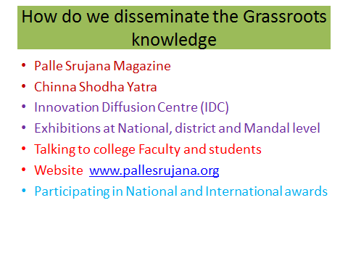
Scouting traditional knowledge is another important activity of Palle Srujana. Three herbal healers’ meets were conducted and documented the knowledge of over 100 healers of humans and animals across Telugu states. Over 10 patents are under various stages of grant for these healers. This is beside normal scouting the volunteers do. Shodha yatra also links us with many such healers and traditional knowledge healers.
Third activity of Palle Srujana is Communication to the formal system. We ventured on an unexplored area which was not paid attention hitherto by the system. Hopefully it is due to default and not design. Having spent over a decade in the capturing grassroots creativity and traditional knowledge, we are sure that the creativity and knowledge @ grassroots is a big asset to the Nation and it should be accounted for, nurtured and recognized. It should be rather supplemented and not to be replaced. See the people as source and not as sinks. Look at them as creators not only as consumers. Pay them for what they are good at and not what they are bad at – as Prof Gupta urges.
Palle Srujana has learnt to respect people and in the bargain we got respect, love and credibility from the society. This is amazing. Today Palle Srujana kutumbam is over 10000 volunteers, consisting of innovators, traditional knowledge holders, subscribers of Palle Srujana magazine, admirers, press and China Shodha yatries in addition to 5 lakh families – beneficiaries of the grassroots innovations. We are growing every day. I am sure some of them would like to join. You are welcome. There is no membership and no filling of forms. Just decide and you are part of Palle Srujana kutumbam.
We explain to Volunteers the scope of the work we do and ask them to contribute in the way they want, whenever they want, whatever they want, how much they want, wherever they want. It should be their plan and their effort and their time. Their willingness leads them to self-accountability. We do not hold any accountable even if they don’t do. Yet, we have so many volunteers and so much has been done. I guess, given a conducive environment, the good ness out of each volunteer emerges. Palle Srujana shares what it understands about volunteerism – which is an art of giving. It has two perspectives. The doer, who will have no expectations form the act. Second the beneficiary – who should feel that he is benefitted by the act of volunteerism in his understanding. Palle Srujana has been able to build a collaborative group by this approach.
In nutshell. Palle Srujana means:
- Our accountability is to Grassroots innovators
- Our work force is volunteers from all segments of society
- Our resource is the goodness of people
- Our dream is to bring equity and sustainability
- Our approach is the firm belief in the creativity of common people
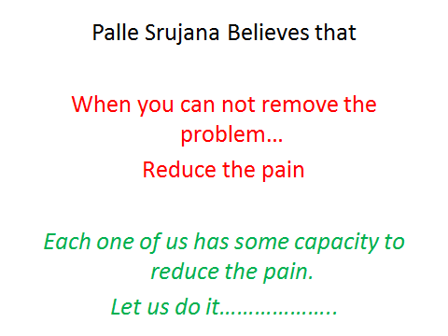
- Our philosophy is “Samvedana”
No Money, No organization, No authority, No targets,
No disappointments, No failures, ……………….
Only Success- however small it is

THIS HAS BEEN MY SECOND LIFE AND LOVED EVERY SECOND OF IT.
We built a group which converges the energies of people like a convex lens, to work for the society voluntarily, with no resources, no responsibilities, no mission, no objectives, no accountability, no T & C and yet able to deliver to the people by the collective and collaborative effort. It has been a highly satisfying activity.
I got unconditional love and affection from innovators and their families. They accepted me as their family elder. Hundreds of Volunteers gave me a lot of respect and adulation and hundreds walked with me for miles and miles.
Together we thought about others and always.
Together we did something for others and always.
Together we lived a life of contentment and contribution

Let me by very honest to you. What I learnt in the second life is much more than I learnt in my first life. I am happy that I made the decision to make my self ZERO and I wish to continue to remain zero to live with excitement and love.
I also seek forgiveness from thousands of people whom I met in both lives for my misdeeds.
I express my deep gratitude to all elders and younger ones- male and female who played a role in my first and second life.
Thanks for your patience to hear the story of two lives.
Brigadier Pogula Ganesham
14 January 2019
president@pallesrujana.org
www.pallesrujana.org
9866001678
Please share your views, comments and suggestions with Brig Ganesham
through president@pallesrujana.org

